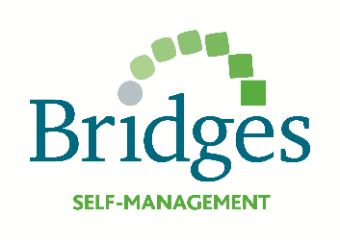

Based on Bridges Open Workshop
An Introduction to Supporting Self-Management in Rehabilitation

Initial Workshop Date: Friday 15 April 2016
Follow up Workshop Date: Friday 24 June 2016
Venue: Room 806 Keyworth Conference Centre, Southbank University, London

Cost £290 (£348 including VAT) Bring a colleague for £260 each (£312 each including VAT)
This includes both workshops, refreshments and lunch, 5 stroke self-management books and all learning materials

Booking Form:
Your name
Your email address
Special dietary requirements
Please let us know who we should send our invoice to:
Name (if different)
Address
Email address

Self-management books
Our workshop cost includes 5 books and you may choose any combination of the books described below. The combination you choose will depend on your caseload e.g. if you work on a stroke unit you will want 5 stroke books; if you work in community neurological rehabilitation team you might choose 3 long-term conditions books and 2 stroke books; if you work on an inpatient rehabilitation unit you might choose 3 traumatic brain injury books and 2 stroke books:

Book Order:
Book Description | Quantity (up to 5 in total)
Stroke self-management books: patient-held workbook and accompanying friends and family booklet. Suitable for stroke survivors and their families
Traumatic brain injury books: patient-held workbook and accompanying friends and family booklet. Suitable for survivors of mild, moderate and severe traumatic brain injury and some cases of acquired brain injury
Long-term conditions books: patient-held workbook only. Suitable for patients with but not limited to; Multiple Sclerosis, Parkinson’s disease, stroke, dementia and other rare neurological conditions

Unfortunately, we cannot send you pdfs of the books prior to making your order. During the initial workshop you will be guided to get to know the books and how to use them in practice. We are happy to change your order after the initial workshop if you feel that other books will better suit your caseload.

Please email your completed form to: chrissy@bridgesselfmanagement.org.uk

